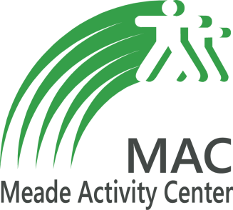
Welcome to the Meade Activity Center REC League Program. The MAC Program is an afterschool program with specific curriculum for students in grades kindergarten through 6th grade. The student may attend the program when their school is dismissed until 5:00 PM (An extended 30 minutes of MAC Game Zone is available free of charge until 5:30 PM). The weekly fee is $52.00 for Non-MAC members and $44.00 for MAC members. Currently, there are two sites, one is held at Flaherty Primary School and the other is at Brandenburg Primary School. The Brandenburg site accepts children from both Brandenburg Primary and David T. Wilson Elementary, and the Flaherty site is available to children from both Flaherty Primary and Flaherty Elementary.
***Included with your child’s weekly fee is a daily meal provided by Meade County School Food Service. Homework and physical activity are both a requirement during the child’s time at the MAC REC League Afterschool Program and staff members assist as needed. Various physical activities are planned each day for students along with other recreational opportunities. Program details are listed below:
- Issues that arise will be handled by MAC Staff. While our programs will be housed in Meade County Schools, the principals and staff that are not employed by the Meade Activity Center will not be involved with the afterschool program.
- A Three Strike disciplinary action system will be utilized. Details of the system will be discussed before the start of the program during orientation.
- The program will only run on days that school is in session. The program will not be live on any holidays, professional development, scheduled breaks, snow-days, early dismissals, OR HALF-DAYS.
- We will need to know about any special needs or allergies/medication that children have in order to make proper arrangements.
- Due to safety concerns, if a child is disruptive or unsafe towards themselves or others they may be removed from the program at the discretion of REC League Staff.
***Contingent upon food service offering the service.
For more information contact Terry Lancaster, the MAC After School Coordinator.
Terry.lancaster@meadeactivitycenter.org
Meade Activity Center 270-422-2227
Terry Lancaster 270-668-8238

